J-Zach Loke

CMPS-368: Principles of Computer Networks

May 21, 2020

**Linksys LGS552P**

52-Port Gigabit POE+ Managed Switch

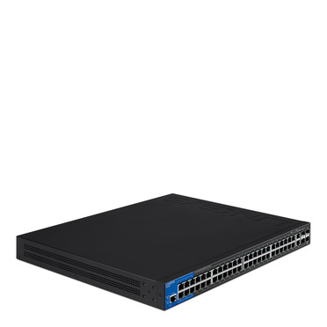

Linksys’ LGS552P is a 52-port PoE+ switch which doesn’t offer a bunch of fancy features, but instead tries to stand out with superior performance and quality.

According to Linksys’ technical specifications, the LGS552P should support port-based VLANs, but doesn’t seem to actually physically support it. As *SmallNetBuilder* reports,“port-based VLANs aren’t mentioned anywhere in the manual. Further, there isn’t a configuration option for enabling port-based VLANs. Moreover, port-based VLANs on an 802.1Q switch require ports that can be untagged members of multiple VLANs, which doesn’t appear to be supported by the LGS552P” (Reid 3). So while Linksys may market the LGS552P as being able to support port-based VLANs, it seems like it was never meant to actually handle it, especially when it’s not mentioned in the manual.

Obviously, a PoE+ switch must be able to provide power to devices over ethernet. Linksys states that the LGS552P can provide up to 375 watts of power to 48 of its 52 ports. While he may not have been trying to test the switch’s absolute limits, Doug Reid of *SmallNetBuilder* was able to draw an average of “7.27 W [per device] to 48 ports” which totaled to roughly 350 W, thus concluding that the LGS552P can provide power to all of its switches and can at least handle up to 350 W (Reid 3).

The heart of a switch like this is its throughput, or how efficiently and reliably the switch can pass along data. On their website, Linksys advertises that the LGS552P supports a gigabit connection. In theory, the switch should read close to a 1000Mbps throughput, but because of several real-world factors, actually achieving such a speed is pretty much impossible. The mark of a good switch should be to get as close to that 1000Mbps mark without sacrificing reliability, consistency, or basic features and functions. In a test performed by *PCMag*’s Samar Lynn, the LGS552P was able to average an 800Mbps throughput which she says is a “very good real-world performance” (Lynn).

The LGS552P also supports some other features such as Spanning Tree Protocol, Link Aggregation Groups, and Quality of Service among others. For the most part, these are all pretty standard on most other dedicated switches of this class. Lynn and Reid of *PCMag* and *SmallNetBuilder* respectively both had nothing of note to mention. When addressing these features, they conclude that they work as expected. This implies that the LGS552P doesn’t do any of these things surprisingly well or surprisingly poorly and that this is on par with what other similar switches offer.

While the LGS552P’s features are standard and don’t stand out, its raw performance capability is what sets it apart from other dedicated switches. *PCMag* was so impressed with it that they named it the PCMag Editors’ Choice for switches, dubbing it the “Datacenter Star”.

**Bibliography**

1. Lynn, S. (2014, November 25). Linksys 52-Port Managed PoE+ Gigabit Switch (LGS552P) Review. Retrieved from <https://www.pcmag.com/reviews/linksys-52-port-managed-poe-plus-gigabit-switch-lgs552p>
2. Reid, D. (2014, August 20). Linksys LGS552P 52-Port Managed PoE+ Gigabit Switch Reviewed. Retrieved from [https://www.smallnetbuilder.com/lanwan/  
   lanwan-reviews/32496-linksys-lgs552p-52-port-managed-poe-gigabit-switch-reviewed?start=0](https://www.smallnetbuilder.com/lanwan/lanwan-reviews/32496-linksys-lgs552p-52-port-managed-poe-gigabit-switch-reviewed?start=0)

Journal Article grading criteria

|  |  |  |  |
| --- | --- | --- | --- |
| Journal Article Criteria | | Possible | Points |
| Points | Awarded |
|  |  |
|  |  |  |  |
| Paper turned in on time | | 5 |  |
| Correct link to article provided | | 5 |  |
| Name, Date, Cover page, purpose, Title, Format | | 5 |  |
| Summary - Accurate to the point | | 5 |  |
| Concept – Valid statement of concept of article | | 5 |  |
| Reaction – Accurate includes information from experience and | | 10 |  |
| other sources | |  |
|  |  |
| Grammar and Style (correct punctuation, Grammar, Appropriate | | 5 |  |
| language etc) | |  |
|  |  |
| Substance and Quality of Writing, Thinking and Presentation | | 10 |  |
|  |  |  |  |
|  | Total | 50 |  |
|  | |  |  |
| Comments | |  |  |
|  |  |  |  |